Name (Pin Yin): _________________________ Student ID _______ Grade: ______

**CQUPT EE310 2020 Fall Quiz 1a**

**(15min, 20pts)**

1. ((4pts) Inputs x & y are shown by the waveforms below. Draw the waveform for the output function (x OR y)

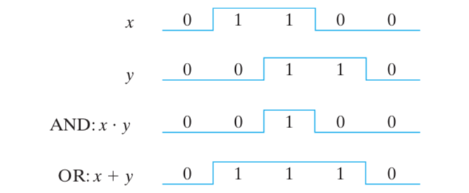

1. (4pts) Apply DeMorgan’s law to the expression: $Y=\overline{AB+CD}$ 2pts each step
$$Y=\overline{AB+CD}=\left(\overline{A}+\overline{B}\right)\left(\overline{C}+\overline{D}\right)$$

2. (4pts) Write the truth table of a 4-to-1 multiplexer. -1pt each error

|  |  |  |  |
| --- | --- | --- | --- |
| EN | S1 | S0 | Y |
| 0 | 0 | 0 |  |
| 0 | 0 | 1 |  |
| 0 | 1 | 0 |  |
| 0 | 1 | 1 |  |
| 1 | 0 | 0 |  |
| 1 | 0 | 1 |  |
| 1 | 1 | 0 |  |
| 1 | 1 | 1 |  |

1. (4pts) Draw the output waveform Q for the given gated SR latch below. Q is 0 initially! -2pts if minor error, -4 if answer makes no sense

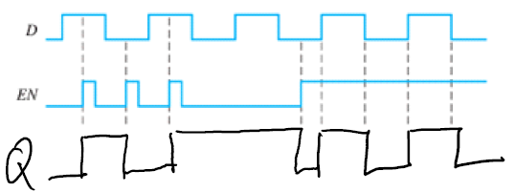

1. (4pts) What is the main difference between FPGA and ASIC? Check graph next page, if the difference is mentioned but not the key different, -1pt

FPGA: hardware is ready before the design

ASIC: Need to go through the whole fabrication process

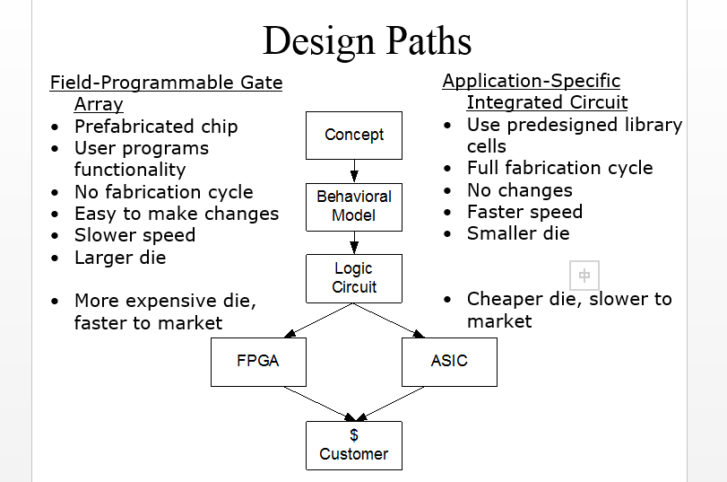

Name (Pin Yin): _________________________ Assign. No. _______ Grade: ______

**CQUPT EE310 2020 Fall Quiz 1b**

**(15min, 20pts)**

1. (4pts) Inputs x & y are shown by the waveforms below. Draw the waveform for the output function (x AND y)

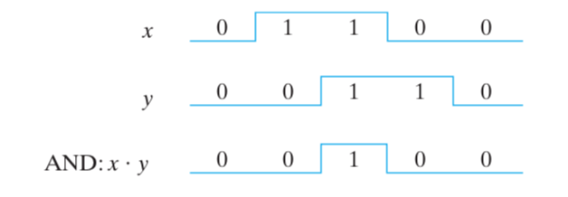

1. (4pts) Apply DeMorgan’s law to the expression: $Y=\overline{(A+B)(C+D)}$-2pts if not get the final result
$$Y=\overline{A+B}+ \overline{C+D}=\overline{A} \overline{B}+\overline{C} \overline{D}$$

2. (4pts) Write the truth table of a 2-to-4 decoder. -1pt each error

|  |  |  |  |  |  |  |
| --- | --- | --- | --- | --- | --- | --- |
| EN | I1 | I0 | Y0 | Y1 | Y2 | Y3 |
| 0 | 0 | 0 | 0 | 0 | 0 | 0 |
| 0 | 0 | 1 | 0 | 0 | 0 | 0 |
| 0 | 1 | 0 | 0 | 0 | 0 | 0 |
| 0 | 1 | 1 | 0 | 0 | 0 | 0 |
| 1 | 0 | 0 | 1 | 0 | 0 | 0 |
| 1 | 0 | 1 | 0 | 1 | 0 | 0 |
| 1 | 1 | 0 | 0 | 0 | 1 | 0 |
| 1 | 1 | 1 | 0 | 0 | 0 | 1 |

1. (4pts) Draw the output waveform Q for the given JK flip-flop below. Q is 0 initially! -2pts if minor error, -4 if answer makes no sense 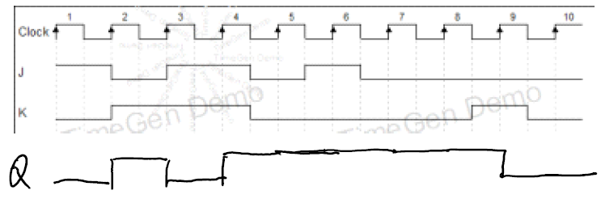
2. (4pts) What is the main difference between FPGA and ASIC? Check graph next page, if the difference is mentioned but not the key different, -1pt

FPGA: hardware is ready before the design

ASIC: Need to go through the whole fabrication process

